Adaptive Research Paper Retrieval using Hybrid Search, AutoML, and Online Learning

Deliverable 1 Report
Group 9 : Alanood Saleh , Batool Masadeh , Batool Mourad , Leen Bastati , Noor Al Swailmeen .

1. Introduction
Retrieval-Augmented Generation (RAG) systems are becoming widely used in large language model applications because they help models retrieve external information before generating responses. However, retrieval quality strongly affects the final system performance. If the retriever fails to find relevant information, the generated answer may become incomplete or incorrect.
This project focused on improving retrieval quality for AI research papers using a hybrid retrieval system combined with automatic optimization and online learning. The system used both TF-IDF keyword retrieval and dense semantic retrieval to search through a dataset of research paper chunks. After retrieval, Optuna AutoML was used to automatically tune the retrieval settings. Finally, online learning and ADWIN drift detection were added to monitor how the system behaves over time.
The full dataset contained 99 AI research papers split into 1,958 text chunks.
This project demonstrates a complete intelligent retrieval pipeline including retrieval optimization, online learning, and concept drift monitoring for AI research paper search.

2. Hybrid Retrieval System
2.1 System Overview
The retrieval system combined two different retrieval approaches:
- TF-IDF keyword retrieval
- Dense semantic retrieval using embeddings
TF-IDF retrieval works well when the query contains exact technical terms. Dense retrieval helps find semantically related chunks even when the wording is different.
A weighted hybrid score was used:
FinalScore = α(DenseScore) + (1 − α)(TFIDFScore)
where:
- α controls the balance between dense retrieval and TF-IDF retrieval
- higher α gives more importance to semantic similarity
- lower α gives more importance to keyword matching
Initially, the system used manually selected settings:
- α = 0.7
- k = 5 retrieved chunks
However, these settings were manually estimated and were not guaranteed to be optimal.

2.2 Retrieval Evaluation
The retrieval system was evaluated using:
- Recall@5
- NDCG@5
- P95 Latency
Recall@5 measures whether the correct chunk appears within the top retrieved results. NDCG@5 measures ranking quality by rewarding highly relevant chunks appearing near the top. P95 Latency measures retrieval speed.

2.3 Baseline Retrieval Results
Table 1: Baseline hybrid retrieval evaluation results
Method |  |  |  | Recall@5 |  |  | NDCG@5 |  |  | P95 Latency
Hybrid Retrieval |  |  |  | 0.9000 |  |  | 0.7771 |  |  | 0.1262 s
The baseline retrieval system already achieved strong recall performance, but ranking quality and latency still had room for improvement.

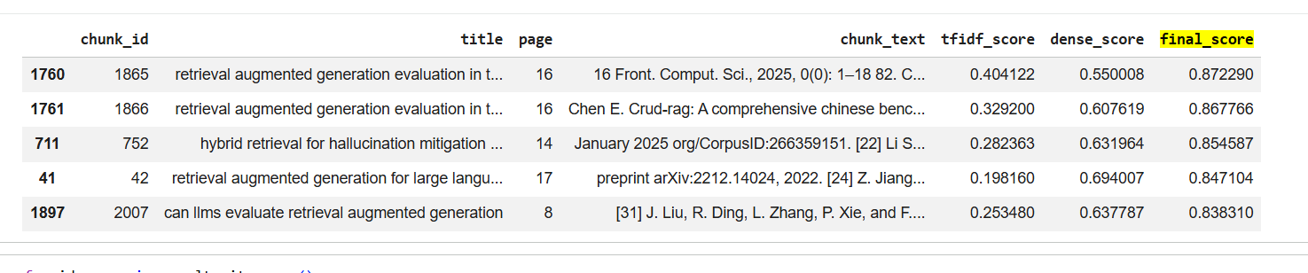
2.4 Example Retrieval Ranking

Figure 1: Ranked retrieval outputs with TF-IDF, dense, and final hybrid scoresThe retrieval outputs show how the hybrid scoring mechanism combines keyword similarity and semantic similarity to rank retrieved chunks. The final score allowed the system to balance exact keyword matching with semantic understanding.
3. AutoML Optimization Using Optuna
3.1 Motivation
The baseline retrieval settings were manually selected. This created two problems:
- the settings might not be optimal
- manually testing many combinations is time-consuming
To solve this problem, Optuna AutoML was used to automatically search for better hyperparameters.

3.2 Optuna Optimization Process
Optuna tested different combinations of:
- k
- alpha
- svd_dim
- normalization
- metric
A total of 40 optimization trials were performed.
Each trial was evaluated using NDCG@5.

3.3 Best Configuration Found
Method |  |  |  |  | Recall@5 |  |  | NDCG@5 |  |  | P95 Latency
Baseline (fixed settings) |  |  |  |  | 0.9000 |  |  | 0.8274 |  |  | 0.0852s
AutoML (Optuna best) |  |  |  |  | 0.9667 |  |  | 0.8479 |  |  | 0.0263s
Table 2: Best hyperparameters found using Optuna

Parameter | Best Value
k | 15
alpha | 0.6439
svd_dim | 500
normalization | False
metric | cosine
The optimized configuration achieved better retrieval quality and lower latency compared to the baseline settings.

3.4 Baseline vs Optimized Results
Method |  |  |  | Recall@5 |  |  |  | NDCG@5 |  |  | P95 Latency
Baseline Retrieval |  |  |  | 0.9000 |  |  |  | 0.8274 |  |  | 0.0852 s
Optuna Optimized Retrieval |  |  |  | 0.9667 |  |  |  | 0.8479 |  |  | 0.0263 s
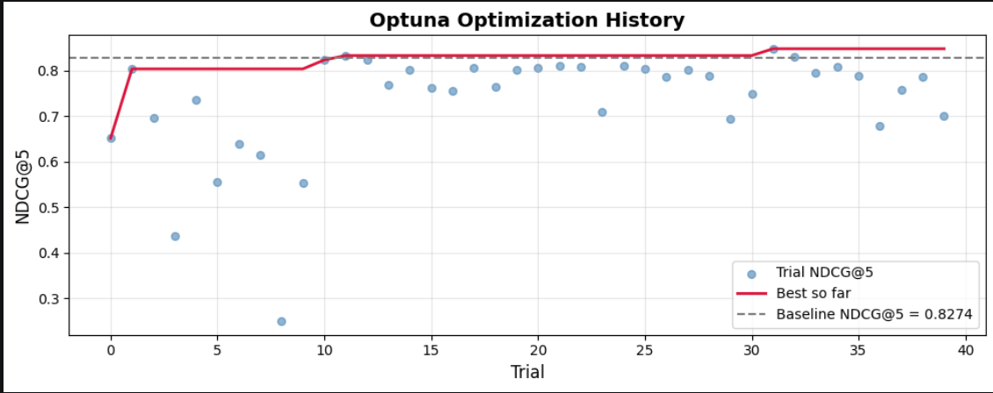Figure 2: Optuna optimization history across 40 trials

The optimized configuration improved recall, ranking quality, and retrieval speed. The latency improvement was especially significant, reducing retrieval time by almost three times.

3.5 Parameter Importance

Parameter |  |  |  | Importance
k |  |  |  | 0.521
svd_dim |  |  |  | 0.214
alpha |  |  |  | 0.116
metric |  |  |  | 0.088
normalization |  |  |  | 0.061
The most important parameter was k, meaning the number of retrieved chunks had the strongest effect on retrieval quality.
The optimized system improved because:
- k = 15 gave more opportunities to retrieve the correct chunk
- alpha = 0.644 balanced semantic and keyword retrieval more effectively
- svd_dim = 500 preserved more retrieval information
- disabling normalization preserved useful score magnitudes

4. Online Learning and Drift Detection
4.1 Motivation
Even after optimization, retrieval systems may change over time because:
- queries change
- data distributions shift
- user behavior evolves
To handle this, online learning and concept drift detection were added.

4.2 Online Learning Pipeline
The optimized retrieval outputs were converted into a streaming feedback dataset.
Each retrieved chunk became one online learning example. The feedback label indicated whether the retrieved chunk matched the gold relevant chunk.
The online learner was implemented using:
- River logistic regression
- incremental learning
- prequential evaluation

4.3 Prequential Evaluation
In prequential evaluation:
- the model predicts first
- prediction quality is measured
- the model then learns from the example
This simulates real-world streaming systems where new data arrives continuously.
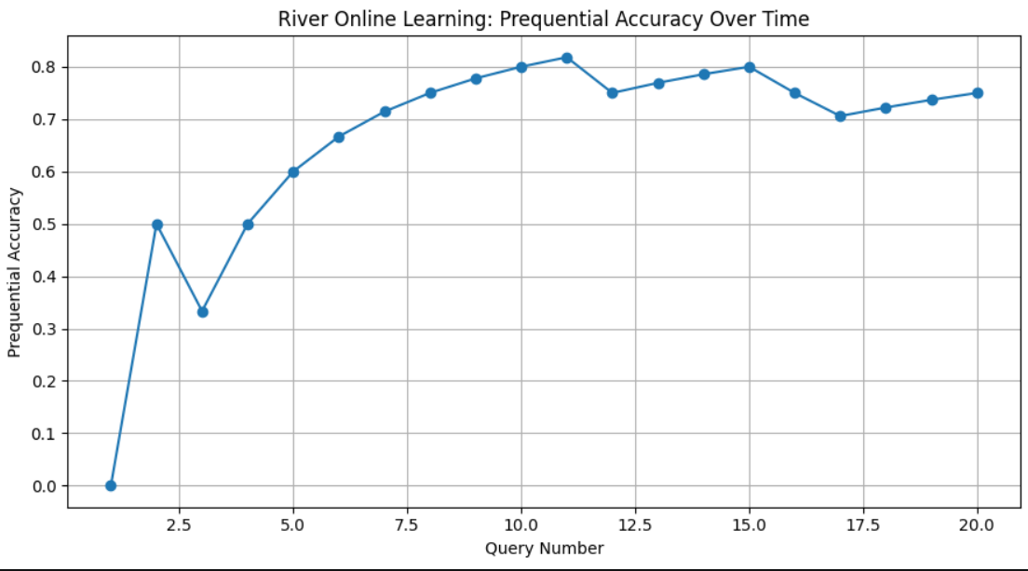 Figure 3: River online learning prequential accuracy over time

The online learning model improved gradually over the query stream and maintained relatively stable retrieval performance.

5. ADWIN Drift Detection
5.1 Drift Detection
ADWIN was used to monitor the online error stream.
ADWIN automatically checks whether the data distribution changes significantly over time. If the error distribution changes suddenly, ADWIN signals concept drift.

5.2 Natural Stream Results
Table 5: Online learning results on natural retrieval stream
Metric | Value
Final Accuracy | 0.9033
Final F1 Score | 0.3830
Drift Events Detected | 0
No natural drift events were detected. This means the retrieval stream remained relatively stable during evaluation.

5.3 Adaptive Hybrid Weight

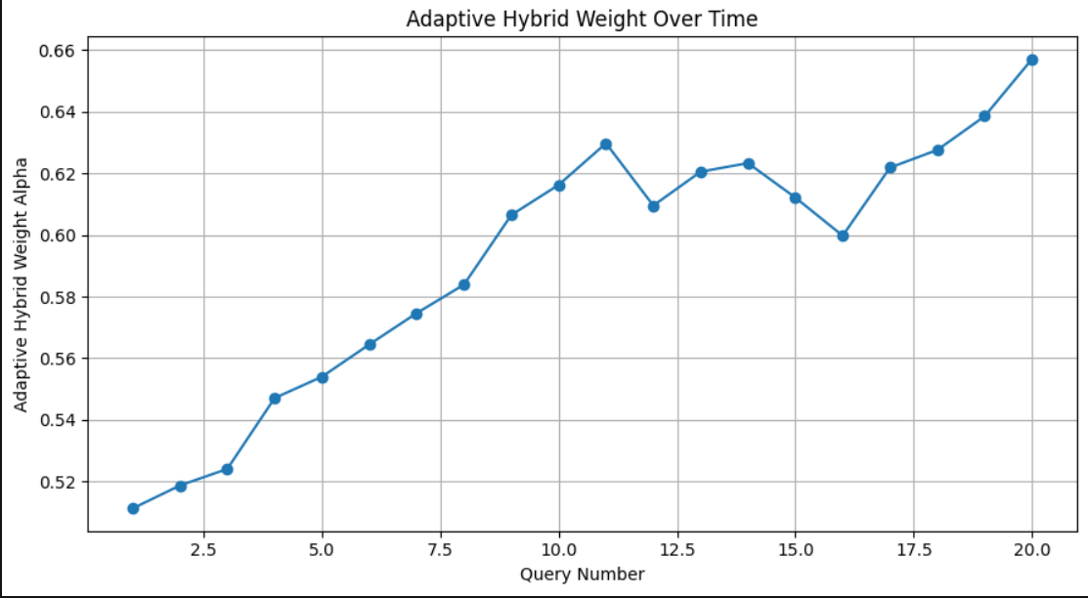 Figure 4: Adaptive hybrid retrieval weight over time

The adaptive alpha mechanism dynamically adjusted the balance between TF-IDF and dense retrieval during online learning.

The adaptive hybrid weight gradually increased over time, showing that semantic retrieval became slightly more important during later queries.

6. Artificial Drift Validation
6.1 Motivation
Because no natural drift appeared, an artificial drift experiment was performed to verify that ADWIN works correctly.
Artificial drift was introduced near the middle of the query stream to simulate a sudden distribution shift.
6.2 Artificial Drift Results
Metric |  |  |  |  |  |  | Value
Artificial Drift Accuracy |  |  |  |  |  |  | 0.56
Artificial Drift F1 |  |  |  |  |  |  | 0.1852
Artificial Drift Events |  |  |  |  |  |  | 1
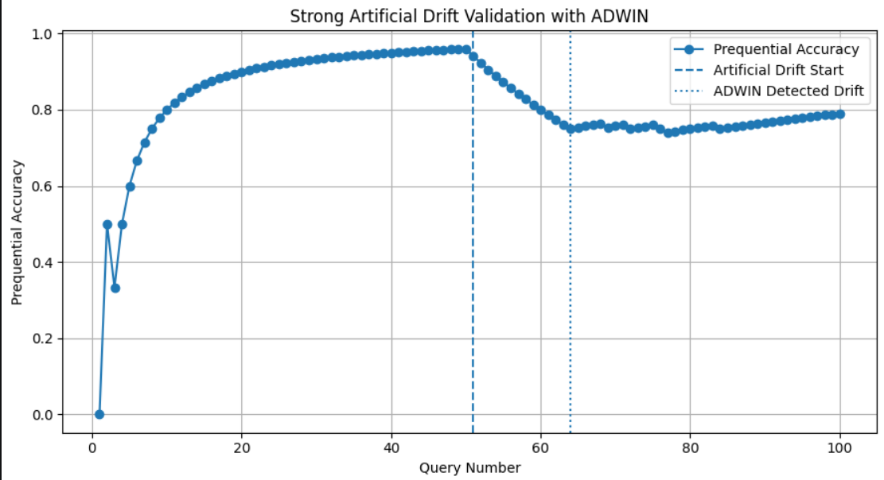 Figure 5: Strong artificial drift validation using ADWIN
After introducing artificial drift, the online learning performance decreased noticeably.
ADWIN successfully detected the distribution change shortly after the drift started.
This validated that the drift detector worked correctly under strong distribution shifts.

7. Discussion
The project showed that combining:
- hybrid retrieval
- AutoML optimization
- online learning
- and drift detection
can significantly improve retrieval system quality.
Several important observations were found:
- retrieving more chunks improved recall strongly
- TF-IDF remained highly important for technical AI terminology
- AutoML successfully improved both quality and speed
- online learning adapted successfully after distribution changes
- ADWIN correctly detected artificial distribution changes
The results also showed that retrieval systems should not rely on fixed manually selected parameters.

8. Conclusion
This project developed an intelligent retrieval system for AI research papers using hybrid retrieval, Optuna AutoML optimization, and online drift detection.
The optimized system improved:
- Recall@5
- NDCG@5
- retrieval latency
Online learning and ADWIN drift detection were then added to monitor retrieval behavior continuously.
The final system demonstrated:
- strong retrieval quality
- adaptive behavior
- adaptive online learning performance
- successful drift detection validation
The project highlights the importance of:
- automatic hyperparameter optimization
- adaptive retrieval systems
- continuous monitoring in modern RAG pipelines
Future work could include larger datasets, transformer-based reranking, and real-time user feedback integration.

References:
1- Lewis, P., Perez, E., Piktus, A., Petroni, F., Karpukhin, V., Goyal, N., Küttler, H., Lewis, M., Yih, W., Rocktäschel, T., Riedel, S., and Kiela, D., “Retrieval-Augmented Generation for Knowledge-Intensive NLP Tasks,” Advances in Neural Information Processing Systems (NeurIPS), vol. 33, pp. 9459–9474, 2020.
2- Baeza-Yates, R. and Ribeiro-Neto, B., Modern Information Retrieval. New York, NY, USA: Addison-Wesley, 2011.
3- Manning, C. D., Raghavan, P., and Schütze, H., Introduction to Information Retrieval. Cambridge, UK: Cambridge University Press, 2008.
4- Pedregosa, F., Varoquaux, G., Gramfort, A., Michel, V., Thirion, B., Grisel, O., Blondel, M., Prettenhofer, P., Weiss, R., Dubourg, V., and others, “Scikit-learn: Machine Learning in Python,” Journal of Machine Learning Research, vol. 12, pp. 2825–2830, 2011.
5- Akiba, T., Sano, S., Yanase, T., Ohta, T., and Koyama, M., “Optuna: A Next-generation Hyperparameter Optimization Framework,” in Proceedings of the 25th ACM SIGKDD International Conference on Knowledge Discovery & Data Mining, 2019, pp. 2623–2631.
6- Montiel, J., Halford, M., Mastelini, S. M., Bolmier, G., Sourty, R., Vaysse, R., and others, “River: Machine Learning for Streaming Data in Python,” Journal of Machine Learning Research, vol. 22, no. 110, pp. 1–8, 2021.
7- Bifet, A. and Gavaldà, R., “Learning from Time-Changing Data with Adaptive Windowing,” in Proceedings of the 2007 SIAM International Conference on Data Mining, 2007, pp. 443–448.

